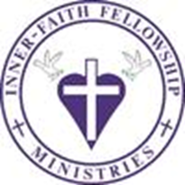

_____ Yes, I will provide sponsorship for your event. If yes, please check your sponsorship level below.

_____ No, I will not provide sponsorship for your event. If no, we understand and thank you in advance.

Sponsorship Levels
*Please check your level of sponsorship below.

_____ Silver: Donation of $100: (Silver level sponsors receive small sized sponsorship decal and three free game tickets).
_____ Bronze: Donation of $250: (Bronze level sponsors receive a medium sized sponsorship decal and five free game tickets)
_____ Gold: Donation of $500: (Gold level sponsors receive a large sized sponsorship decal and eight free game tickets)
_____ Other: Donation less than $100: Specify donation amount or type below:

Business Name:_________________________________________________
Phone #:_______________________________________
Email: ___________________________________

Please return all sponsorship agreements and items to P.O. 737 Rocky Mount, VA 24151 OR call or text 434.579.8387 (Keona Walton) to arrange pick-up. We thank you in advance for your gift. May God bless you and continue to shine upon your business endeavors! For more information about our church please visit our church website below.

Thank you in advance,
Inner Faith Fellowship Ministries~

